**Quiz 2 (time limit is till 7.00 PM Evening) Total Marks 10**

**Note: solve this quiz on separate page scan it and submit to me on time after 7.00 I won’t accept and no late submissions, please)**

This problem continues the Let’s Bike Company situation from Chapter 13. Let’s Bike Company’s comparative balance sheet is shown below.

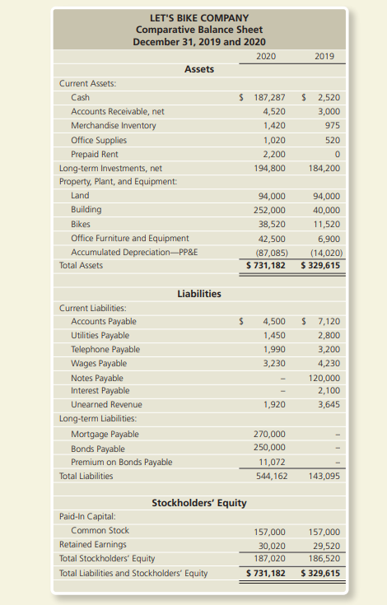

Additional data follow:

1. The income statement for 2020 included the following items:

a. Net income, $3,200.

b. Depreciation expense for the year, $73,065.

c. Amortization on the bonds payable, $1,007.

2. There were no disposals of property, plant and equipment during the year. All acquisitions of PP&E were for cash.

3. There were neither purchase nor disposal of long-term investments. The increase in balance of long-term investments was entirely due to the increase in the fair value which has been included in the net income.

4. The company issued bonds payable with a face value of $250,000, receiving cash of $262,079. 5. The cash receipt from the notes payable in 2019 is considered a financing activity because it does not relate to operations.

**Requirement**

Prepare the statement of cash flows for the year ended December 31, 2020, using the indirect method.

**Quiz 3 (time limit is till 7.00 PM Evening) Total Marks 10**

**Note: solve this quiz on separate page scan it and submit to me on time after 7.00 I won’t accept and no late submissions, please)**

A-One Mobile Homes reported the following in its financial statements for the year ended December 31, 2018.

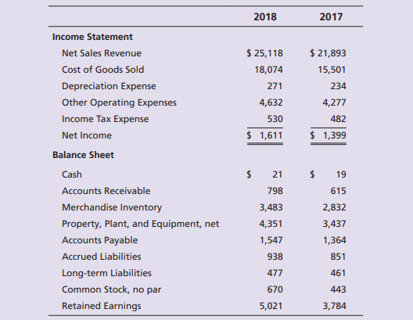

**Requirements**

1. Compute the collections from customers.

2. Compute payments for merchandise inventory.

3. Compute payments of other operating expenses.

4. Compute the acquisitions of property, plant, and equipment (no sales of property during 2018).

5. Compute the amount of borrowing, with A-One paying no long-term liabilities.

6. Compute the cash receipt from issuance of common stock.

7. Compute the payment of cash dividends